VBA Challenge Homework Screenshots of Results

2016 Screenshot

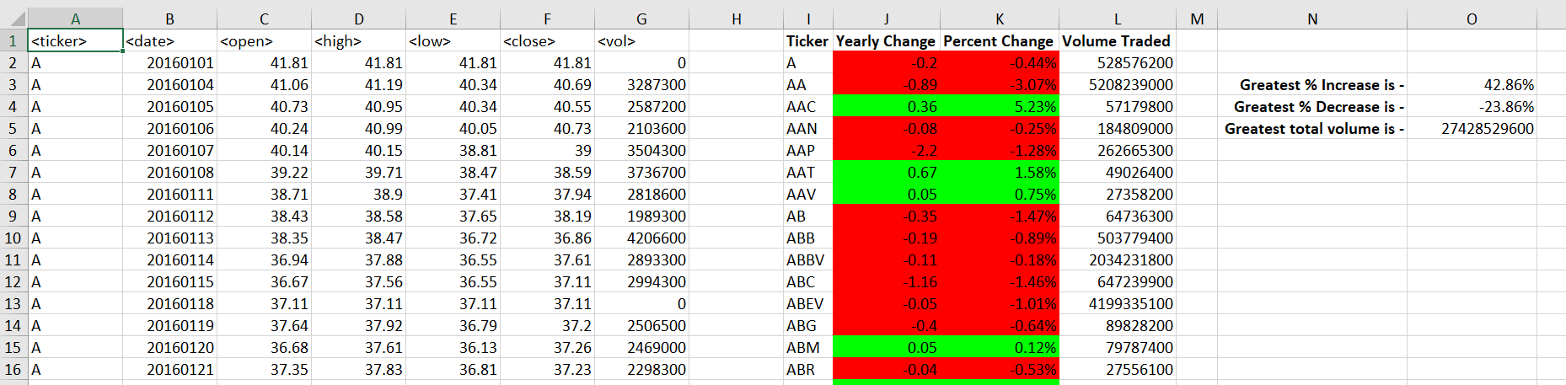

2015 Screenshot

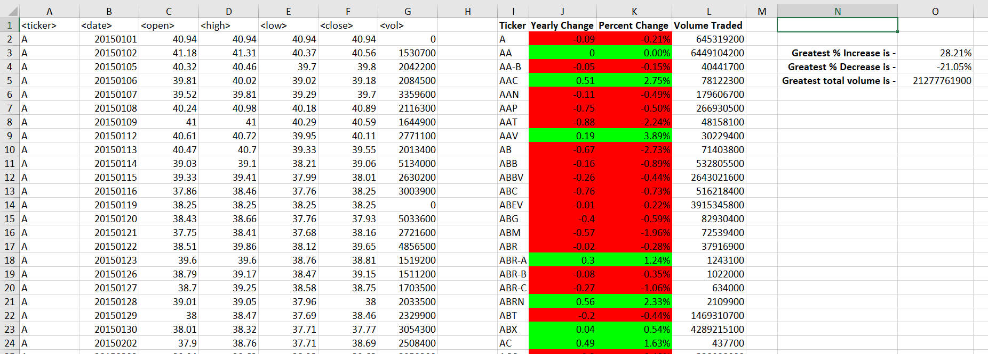

2014 Screenshot

The result values stop at PLD as the next Ticker PLNT has all zeros for values and I get an overflow error. Was not able to determine logic to overcome this challenge. This is also why the increase, decrease and volume results did not publish in column ‘O’.

